An invitation to All Northern Divers An Open Fun Competition If you agree DIVING IS FUN Why not show it by following these three steps
1 Have a fun diving experience 2 Take a picture (using any kind of imaging device) Above or below water. The FUN element is far more important than photographic perfection 3 Send it to the NORFED 2018 Diving is Fun Competition
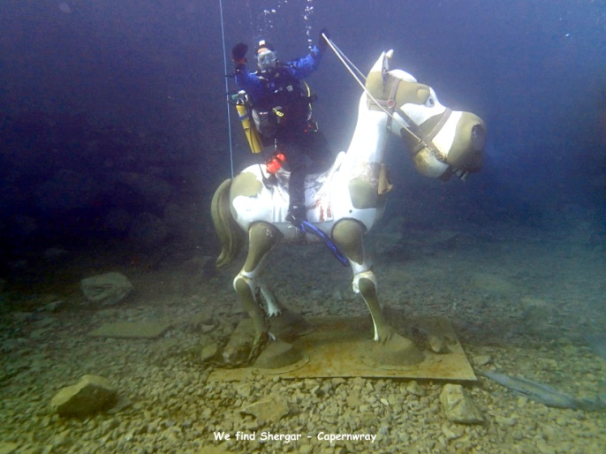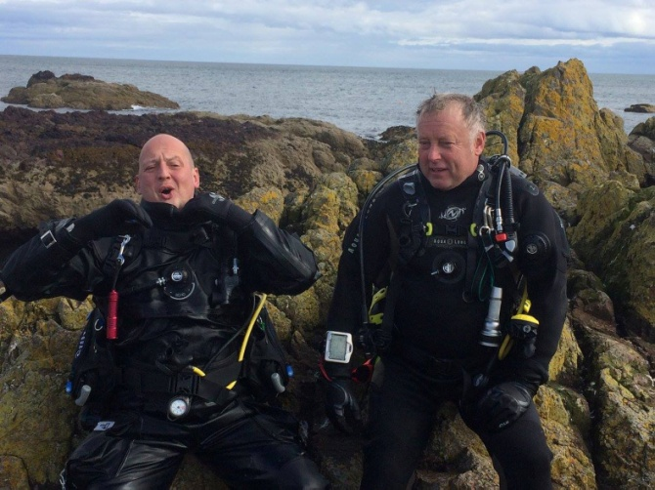
This is a fun event and although there will be a winner/winners trophy/trophies, there are no major prizes There are no pre-requisites, NO entry fee and NORFED membership is not required. Sorry! Here’s the boring bit Select up to 3 of your pictures, ensure they are titled and that your contact details are attached Send them to the address below (not email), together with a prepaid means of returning if required Film/video/A-V presentation max length 3 mins. All entries to be received by Saturday 27th October2018 They will be shown during the NORFED 60th Anniversary Celebration Weekend on Saturday 3rd November 2018 all welcome (see the NORFED website for location details) The results and a selection of entries will be published on the NORFED website and may be used to publicise the BSAC and/or Northern Dive Clubs. In the event of a query the judge’s decision is final
NORFED ‘Diving is Fun’ Competition, c/o Robin Hood Watersports, 152 Leeds Road, Heckmondwike, West Yorkshire, WF16 9BJ
Organised by NORFED - Ken Crow, Tel 0113 257 2112
It’s only a bit of fun, why not make it your Fun

